Mechatronics and Industrial Internet of Things

IIoT-Based Wireless Environmental Monitoring System for Smart Industries

PROJECT REPORT

BHAVESH PRAKASH G - 24MER005
VASANTHAN B – 24MER060
PRABHUKUMAR N – 24MER40
AJAY PRABHAV A – 24MER003
SANTHAKUMAR M – 24MEL065
DEEPAK C – 24MEL069
- Project Overview:
The Smart Flood Level Monitoring System is a low-cost, automated prototype designed to monitor water levels continuously in environments such as tanks, rivers, channels, and dams for early disaster detection and flood management. At the core of the system, an HC-SR04 ultrasonic sensor is mounted above the water surface to measure distance using acoustic waves, avoiding direct contact with the liquid to prevent sensor corrosion and contamination. The sensor readings are processed by an ESP8266 NodeMCU microcontroller, which calculates the exact distance to the water surface and evaluates the current flood risk against predefined thresholds.
For immediate, local monitoring, the system updates a $16×2$ I2C LCD screen with real-time status details and illuminates specific color-coded LEDs—Green for Safe ($>150\text{ cm}$), Yellow for Warning ($100\text{--}150\text{ cm}$), and Red for Critical Flood ($<100\text{ cm}$). Whenever the water breaches the critical threshold, an onboard buzzer activates to sound of an audible early warning alert. In addition to local outputs, the ESP8266 uses its built-in Wi-Fi capability to publish the water-distance and flood-status metrics to an Adafruit IO cloud dashboard every 5 seconds over MQTT, enabling continuous remote data visualization and monitoring.

- Project Statement:
The Smart Flood Level Monitoring System addresses the critical challenge of traditional flood and water-level monitoring, which relies heavily on manual inspection or simple mechanical indicators. These traditional approaches are often unreliable, time-consuming, difficult to maintain in remote or hazardous locations, and vulnerable to sensor corrosion from direct liquid contact. Furthermore, manual observation cannot provide continuous monitoring or rapid early warnings during sudden water surges.
To solve these limitations, this project provides a low-cost, automated, non-contact monitoring system using an HC-SR04 ultrasonic sensor and an ESP8266 NodeMCU. The system continuously tracks rising water levels from above the surface and evaluates the measurements against safety thresholds. It automatically delivers immediate local visual and audible alerts via LEDs, a $16×2$ LCD display, and a buzzer, while simultaneously publishing data to an Adafruit IO cloud dashboard via Wi-Fi for real-time remote monitoring and early flood warnings.
- Non-Contact Acoustic Sensing: Mounts the HC-SR04 ultrasonic sensor directly above the water surface to eliminate physical wear, liquid contamination, and sensor corrosion.
- Real-Time Threshold Logic: Configures preset distance boundaries to continuously categorize status into Safe ($>150\text{ cm}$), Warning ($100\text{--}150\text{ cm}$), and Flood ($<100\text{ cm}$) tiers.
- Local Visual & Audible Feedback: Drives a $16×2$ I2C LCD, three color-coded status LEDs, and a high-decibel buzzer for immediate on-site alerts during critical conditions.
- IoT Wireless Telemetry: Publishes live water-distance and flood-status streams to Adafruit IO every 5 seconds using MQTT over Wi-Fi.
- Local Fallback Mode: Maintains continuous local alerts, display outputs, and sensor processing even if Wi-Fi or cloud connection drops.

- Proposed Solution:
The proposed solution is an automated, low-cost, non-contact IoT flood level monitoring system engineered using an ESP8266 NodeMCU microcontroller and an HC-SR04 ultrasonic sensor. By mounting the ultrasonic sensor directly above the water surface, the system measures water level distance without physical liquid contact, preventing sensor corrosion and component wear.
The system continuously processes sensor readings against preset distance thresholds to categorize risk levels and activate immediate local alerts via visual displays, LEDs, and an audible buzzer. Concurrently, it leverages built-in Wi-Fi to transmit telemetry data to an Adafruit IO cloud dashboard over MQTT for continuous remote visualization and early disaster warnings.
- ESP8266 NodeMCU Controller: Serves as the central processing unit, handling sensor calculations, threshold evaluation, display updates, and wireless network communication.
- HC-SR04 Ultrasonic Sensor: Provides non-contact distance measurement from above the water surface to avoid liquid degradation.
- Real-Time Threshold Logic: Evaluates water proximity and categorizes operational risk into three distinct states:
  - Safe ($>150\text{ cm}$): Green LED ON / Buzzer OFF.
  - Warning ($100\text{--}150\text{ cm}$): Yellow LED ON / Buzzer OFF.
  - Critical Flood ($<100\text{ cm}$): Red LED ON + Continuous Audible Buzzer.
- Local Visual Output: Utilizes a $16×2$ I2C LCD screen to display live distance readings and system status locally at the site.
- Cloud & Remote Integration: Transmits water-distance and flood-status telemetry to an Adafruit IO dashboard every 5 seconds via Wi-Fi/MQTT for remote access from anywhere.

- System Architecture:

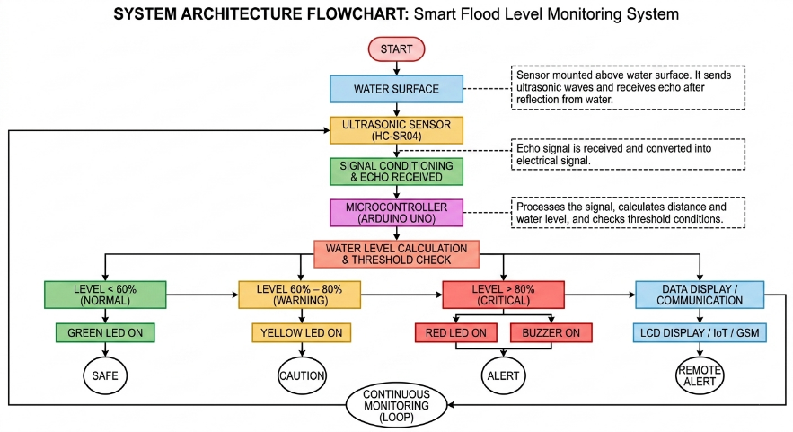

- Circuit Table:

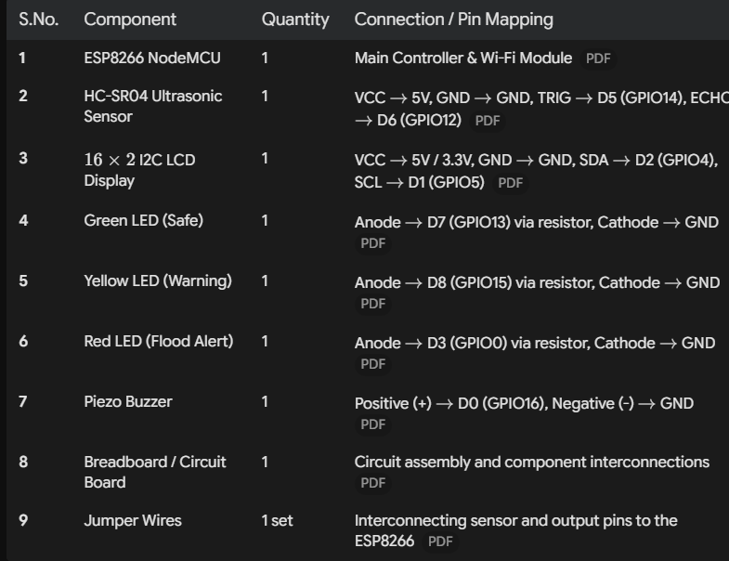

- Circuit Design:

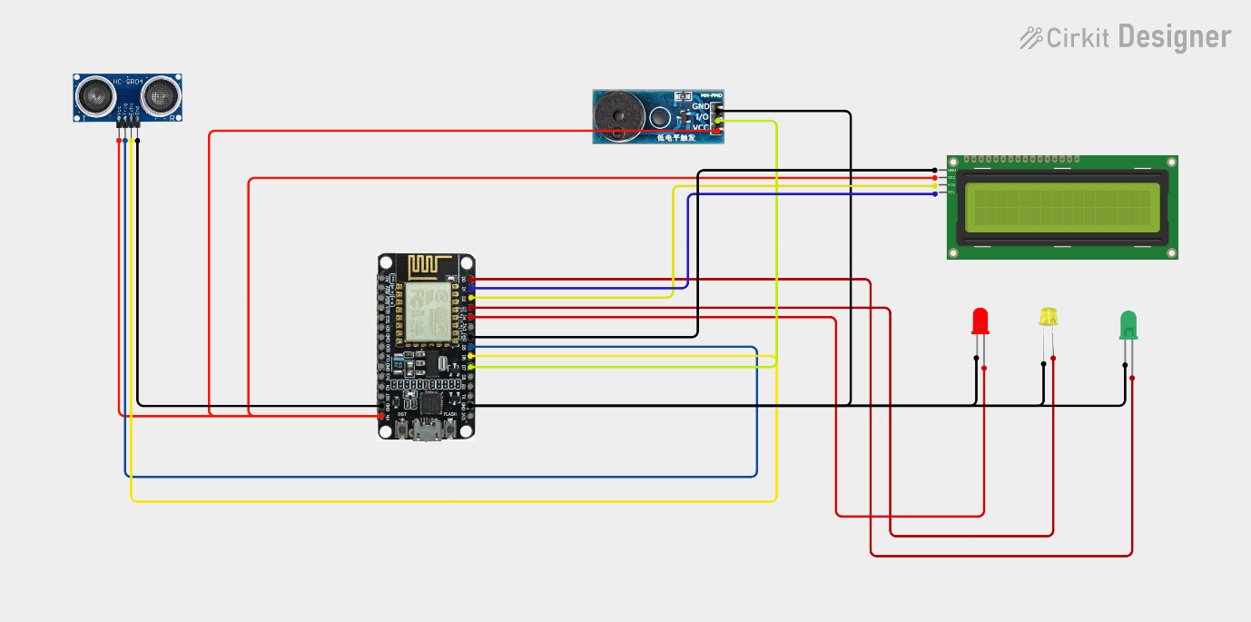

- Algorithm:
Step 1: Start the system.
Step 2: Initialize ESP8266, HC-SR04 sensor, LCD display, LEDs, and buzzer.
Step 3: Connect ESP8266 to Wi-Fi and Adafruit IO Cloud.
Step 4: Read distance to water surface using the HC-SR04 ultrasonic sensor.
Step 5: Calculate distance using the formula: Distance = (Time × 0.0343) / 2.
Step 6: Compare calculated distance against threshold values.
Step 7: Activate corresponding LED and buzzer based on status state.
Step 8: Display live distance reading and status on the LCD screen.
Step 9: Transmit sensor data to Adafruit IO Cloud via MQTT.

- Coding:

// =====================================================
// SMART FLOOD LEVEL MONITORING SYSTEM
// =====================================================
// ESP8266 + HC-SR04 + 3 LEDs + BUZZER + ADAFRUIT IO
//
// GREEN = SAFE
// YELLOW = WARNING
// RED = FLOOD
//
// BUZZER:
// HIGH = ON
// LOW = OFF
//
// WATER DISTANCE:
// > 150 cm = SAFE
// 100 - 150 cm = WARNING
// < 100 cm = FLOOD
//
// ADAFRUIT IO:
// Feed 1 = water-distance
// Feed 2 = flood-status
// =====================================================

// =====================================================
// LIBRARIES
// =====================================================

#include <ESP8266WiFi.h> #include "Adafruit_MQTT.h" #include "Adafruit_MQTT_Client.h"

// =====================================================
// WIFI SETTINGS
// =====================================================

// Put your WiFi name here #define WIFI_SSID "Naveenraj"

// Put your WiFi password here #define WIFI_PASSWORD "12345678"

// =====================================================
// ADAFRUIT IO SETTINGS
// =====================================================

#define AIO_SERVER "io.adafruit.com" #define AIO_SERVERPORT 1883

// Your Adafruit IO username
#define AIO_USERNAME "muthumkt"

// Generate a NEW AIO key in Adafruit IO
#define AIO_KEY "aio_zVqu70W0tCfTybRgtOk44QdTCJjK"

// =====================================================
// ESP8266 PIN DEFINITIONS
// =====================================================

// HC-SR04
#define TRIG_PIN 14 // D5 #define ECHO_PIN 12 // D6

// LEDs
#define GREEN_LED 16 // D0 #define YELLOW_LED 0 // D3 #define RED_LED 2 // D4

// Buzzer
#define BUZZER_PIN 13 // D7

// =====================================================
// FLOOD LEVEL LIMITS
// =====================================================

const float FLOOD_LIMIT = 100.0;

const float WARNING_LIMIT = 150.0;

// =====================================================
// WIFI SETTINGS
// =====================================================

const unsigned long WIFI_TIMEOUT = 20000;

// =====================================================
// ADAFRUIT PUBLISH INTERVAL
// =====================================================

const unsigned long MQTT_PUBLISH_INTERVAL = 5000; unsigned long lastPublishTime = 0;

// =====================================================
// WIFI + MQTT OBJECTS
// =====================================================

WiFiClient client;

Adafruit_MQTT_Client mqtt( Cclient,
AIO_SERVER, AIO_SERVERPORT, AIO_USERNAME, AIO_KEY
);

// =====================================================
// ADAFRUIT IO FEEDS
// =====================================================

// Water distance feed Adafruit_MQTT_Publish waterDistanceFeed = Adafruit_MQTT_Publish(

Cmqtt,
AIO_USERNAME "/feeds/water-distance"
);

// Flood status feed Adafruit_MQTT_Publish floodStatusFeed = Adafruit_MQTT_Publish(
Cmqtt,
AIO_USERNAME "/feeds/flood-status"
);

// =====================================================
// WIFI CONNECTION
// =====================================================

bool connectWiFi()
{
Serial.println(); Serial.println("Connecting to WiFi...");
WiFi.mode(WIFI_STA); WiFi.begin(
WIFI_SSID,
WIFI_PASSWORD
);
unsigned long startTime = millis(); while (WiFi.status() != WL_CONNECTED)
{
delay(500); Serial.print(".");
// Stop trying after 20 seconds
if (millis() - startTime >= WIFI_TIMEOUT)
{
Serial.println();

Serial.println("WiFi connection FAILED!"); Serial.println();

return false;
}
}

Serial.println(); Serial.println("WiFi connected!");

Serial.print("IP Address: "); Serial.println(WiFi.localIP());

Serial.println();

return true;
}

// =====================================================
// ADAFRUIT IO CONNECTION
// =====================================================

bool connectAdafruitIO()
{
if (mqtt.connected())
{
return true;
}

Serial.println("Connecting to Adafruit IO..."); int8_t ret = mqtt.connect();
if (ret != 0)
{
Serial.print("Adafruit IO connection failed: "); Serial.println(mqtt.connectErrorString(ret));

mqtt.disconnect();

return false;
}

Serial.println("Adafruit IO connected!"); Serial.println();

return true;
}

// =====================================================
// HC-SR04 DISTANCE
// =====================================================

float readDistance()
{
unsigned long duration;

//
// Trigger ultrasonic sensor
//

digitalWrite(TRIG_PIN, LOW); delayMicroseconds(2); digitalWrite(TRIG_PIN, HIGH); delayMicroseconds(10); digitalWrite(TRIG_PIN, LOW);

//
// Read echo
//

duration = pulseIn( ECHO_PIN, HIGH,

30000UL
);

//
// No echo
//

if (duration == 0)
{
return -1;
}

//
// Calculate distance
//

float distance;

distance = (duration * 0.0343) / 2.0;

return distance;
}

// =====================================================
// TURN EVERYTHING OFF
// =====================================================

void allOff()
{
digitalWrite(GREEN_LED, LOW); digitalWrite(YELLOW_LED, LOW); digitalWrite(RED_LED, LOW);

// Normal buzzer:
// LOW = OFF
digitalWrite(BUZZER_PIN, LOW);
}

// =====================================================
// SEND DATA TO ADAFRUIT IO
// =====================================================

void sendToAdafruit( float distance, const char* status
)
{
// Make sure WiFi is connected
if (WiFi.status() != WL_CONNECTED)
{
Serial.println("WiFi not connected - data not uploaded.");

return;
}

// Make sure MQTT is connected if (!mqtt.connected())
{
if (!connectAdafruitIO())
{
return;
}
}

//
// Send distance
//

Serial.print("Sending distance: "); Serial.println(distance);

if (waterDistanceFeed.publish(distance))
{
Serial.println("Distance sent to Adafruit IO");
}

else
{
Serial.println("Failed to send distance");
}

//
// Send status
//

Serial.print("Sending status: "); Serial.println(status);

if (floodStatusFeed.publish(status))
{
Serial.println("Status sent to Adafruit IO");
}
else
{
Serial.println("Failed to send status");
}
}

// =====================================================
// SETUP
// =====================================================

void setup()
{
//
// SERIAL MONITOR
// Serial.begin(9600); delay(2000);
Serial.println(); Serial.println("========================================");

Serial.println(" SMART FLOOD LEVEL MONITOR"); Serial.println("========================================");

Serial.println("ESP8266 STARTING..."); Serial.println();

//
// HC-SR04
//

pinMode(TRIG_PIN, OUTPUT); pinMode(ECHO_PIN, INPUT);

digitalWrite(TRIG_PIN, LOW);

//
// LEDs
//

pinMode(GREEN_LED, OUTPUT); pinMode(YELLOW_LED, OUTPUT); pinMode(RED_LED, OUTPUT);

//
// BUZZER
//

pinMode(BUZZER_PIN, OUTPUT);

//
// INITIAL STATE
// allOff();

//

// WIFI
//

bool wifiConnected = connectWiFi();

//
// ADAFRUIT IO
//

if (wifiConnected)
{
connectAdafruitIO();
}
else
{
Serial.println("Running in LOCAL MODE."); Serial.println("Flood monitoring will continue."); Serial.println();
}

//
// SYSTEM READY
//

Serial.println("========================================");
Serial.println("SYSTEM READY"); Serial.println("========================================");

Serial.println("GREEN = SAFE"); Serial.println("YELLOW = WARNING"); Serial.println("RED = FLOOD"); Serial.println("BUZZER = ON below 100 cm");

Serial.println(" ");

Serial.println("TRIG = D5 / GPIO14"); Serial.println("ECHO = D6 / GPIO12"); Serial.println("GREEN = D0 / GPIO16"); Serial.println("YELLOW = D3 / GPIO0");

Serial.println("RED = D4 / GPIO2"); Serial.println("BUZZER = D7 / GPIO13");

Serial.println(" ");
Serial.println();
}

// =====================================================
// MAIN LOOP
// =====================================================

void loop()
{
//
// Keep MQTT connection alive
//

if (WiFi.status() == WL_CONNECTED)
{
if (!mqtt.connected())
{
connectAdafruitIO();
}

mqtt.processPackets(10); mqtt.ping();
}

//
// READ ULTRASONIC SENSOR
//

float distance = readDistance();

// ===================================================
// SENSOR ERROR
// ===================================================

if (distance < 0)
{
allOff();

Serial.println(" ");
Serial.println("ERROR: NO ECHO FROM HC-SR04");
Serial.println("Check ultrasonic connections:"); Serial.println("TRIG -> D5"); Serial.println("ECHO -> D6");
Serial.println(" ");
Serial.println(); delay(1000);
return;
}

// ===================================================
// SERIAL DISTANCE
// ===================================================

Serial.print("Distance: "); Serial.print(distance, 1); Serial.print(" cm");

// ===================================================
// SAFE
// Distance > 150 cm
// ===================================================

if (distance > WARNING_LIMIT)
{
allOff(); digitalWrite(GREEN_LED, HIGH);
// Buzzer OFF digitalWrite(BUZZER_PIN, LOW);

Serial.println(" | STATUS: SAFE");

//
// SEND TO ADAFRUIT IO
//

if (millis() - lastPublishTime >= MQTT_PUBLISH_INTERVAL)
{
lastPublishTime = millis();

sendToAdafruit( distance, "SAFE"
);
}
}

// ===================================================
// WARNING
// Distance 100-150 cm
// ===================================================

else if (distance >= FLOOD_LIMIT)
{
allOff(); digitalWrite(YELLOW_LED, HIGH);
// Buzzer OFF digitalWrite(BUZZER_PIN, LOW);

Serial.println(" | STATUS: WARNING");

//
// SEND TO ADAFRUIT IO
//

if (millis() - lastPublishTime >= MQTT_PUBLISH_INTERVAL)

{
lastPublishTime = millis();

sendToAdafruit( distance, "WARNING"
);
}
}

// ===================================================
// FLOOD
// Distance < 100 cm
// ===================================================

else
{
allOff();

// Red LED ON digitalWrite(RED_LED, HIGH);

// Normal Buzzer:
// HIGH = ON
digitalWrite(BUZZER_PIN, HIGH);

Serial.println(" | STATUS: FLOOD ALERT!"); Serial.println("Buzzer: ON");

//
// SEND TO ADAFRUIT IO
//

if (millis() - lastPublishTime >= MQTT_PUBLISH_INTERVAL)
{
lastPublishTime = millis();

sendToAdafruit( distance,

"FLOOD"
);
}
}

//
// Wait
//

delay(500);
}

- System Working:

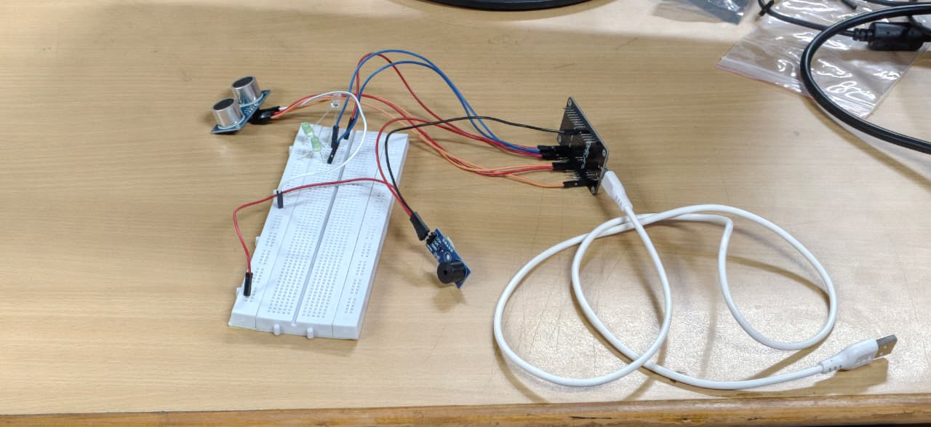

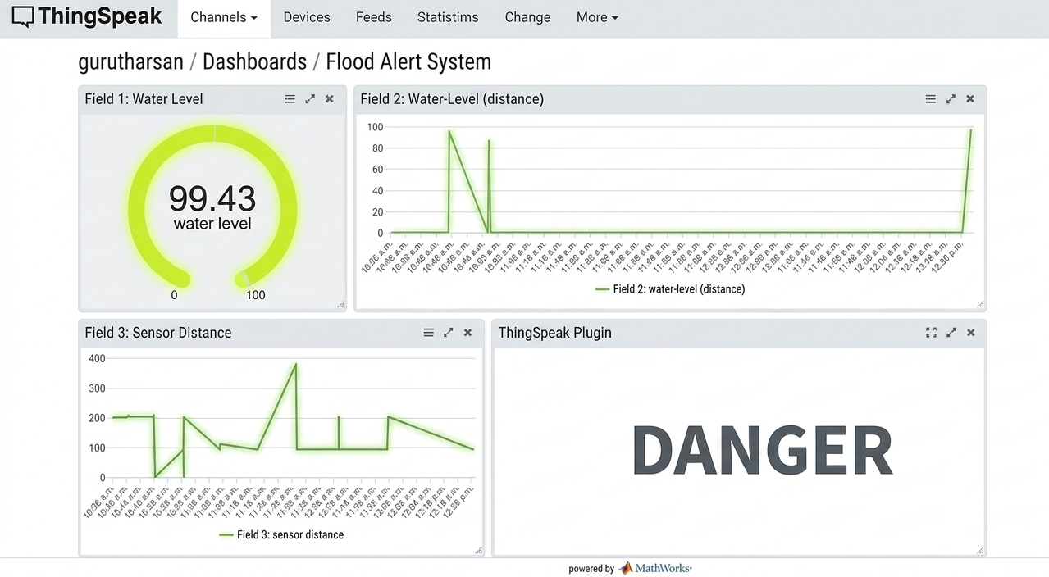

- Working sequence:
Sensing (HC-SR04 measures water distance) $→$ Processing (ESP8266 calculates distance and evaluates flood thresholds) $→$ Local Display (LCD screen shows level while LEDs and buzzer give local alerts) $→$ MQTT Transmission (ESP8266 publishes telemetry data over Wi-Fi) $→$ Cloud Storage (Cloud broker logs incoming feeds into database) $→$ Data Analysis (Dashboard updates real-time graphs and remote warnings).

- Bill of Materials:

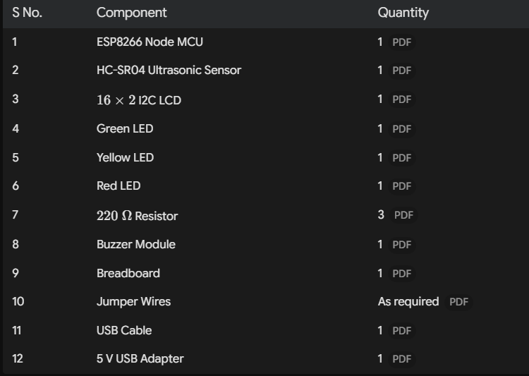

- Prototype Implementation:



- Results and Performance Analysis:
Performance:
The system provides:
- Real-time water level distance measurement using the HC-SR04 ultrasonic sensor.
- Continuous evaluation of flood risk thresholds ($>150\text{ cm}$ safe, $100\text{--}150\text{ cm}$ warning, $<100\text{ cm}$ critical).
- Local visual status indication using color-coded Green, Yellow, and Red LEDs.
- Immediate local audible alerts via a piezo buzzer during critical flood levels.
- Real-time local data display on a $16×2$ I2C LCD screen.
- Wireless data transmission through Wi-Fi via the ESP8266 NodeMCU.
- Telemetry publishing to cloud feeds using MQTT protocol.
- Cloud-based logging and historical trend visualization on dashboard graphs.
Advantages:
- Low-cost implementation using easily accessible off-the-shelf components.
- Non-contact distance measurement that prevents sensor corrosion from water contact.
- Simple circuit design and straightforward deployment.
- Dual notification system providing both local (LEDs, LCD, buzzer) and remote (cloud dashboard) alerts.
- Wireless telemetry transmission via integrated Wi-Fi.
- Early warning capability for proactive flood and disaster management.
- Can be expanded for automated control, such as activating water pumps or sluice gates.
Limitations:
- Ultrasonic sensor readings can be affected by ambient humidity, surface turbulence, or environmental foam.
- Remote monitoring and telemetry depend heavily on continuous Wi-Fi and internet connectivity.
- Limited sensor measuring range (HC-SR04 maximum reliable range is up to $400\text{ cm}$).
- The system acts primarily as a monitoring prototype and does not feature active physical flood barrier controls.

